Task No & Title: | BSBCMN107A Operate a Personal Computer

Title:
Suitable for Classes: | Certificate II Business
Area: | Technology & Enterprise
Teacher: | Mr Peter Faulks
Timeline | 1 Lesson
Date Due: | Today

Task Brief:

Files Required

Items highlighted in yellow are tasks for you to complete
Items in Purple are help tips
10
National Corporate Training

Unit | Number | Title | Study Time
1 | BSBCMN201A | Work effectively in a business environment | 20
2 | BSBCMN202A | Organize and complete daily work activities | 15
3 | BSBCMN203A | Communicate in the workplace | 30  
4 | BSBCMN204A | Work effectively with others | 20
5 | BSBCMN205A | Use business technology | 30
6 | BSBCMN211A | Participate in workplace safety procedures | 15
7 | BSBCMN213A | Produce simple word processed documents | 40
8 | BSBCMN214A | Create and use simple spreadsheets | 20
9 | BSBCMN108A | Develop keyboard skills | 40
10 | BSBCMN107A | Operate a Personal Computer | 20
11 | ICAITU013C | Integrate Commercial computer packages | 30
12 | ICAITU012C | Design Organizational Documents using computer | 50
 |  | TOTAL

Operate a Personal Computer
Cert II in Business - Hardware Peripherals
Cert II in Information Technology- Hardware Peripherals

Complete this sheet and show to Mr Faulks

These were the peripherals available in our IT classrooms

This example shows a Mac system.

I can also use all peripherals on IBM PCs.

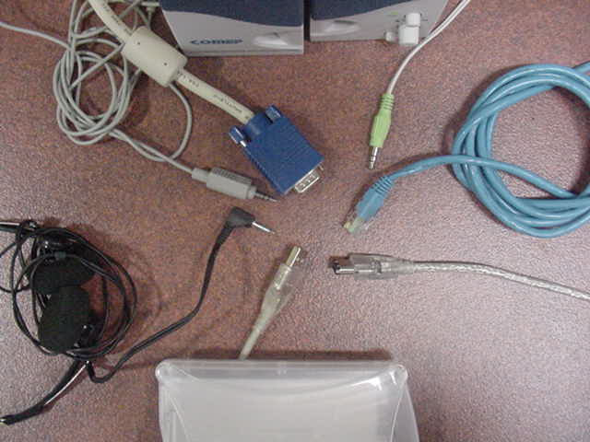
Draw arrows to identify each cable note there may be more than listed

Headphone MiniDIN Video Ethernet (network) Firewire USB Mini Speaker

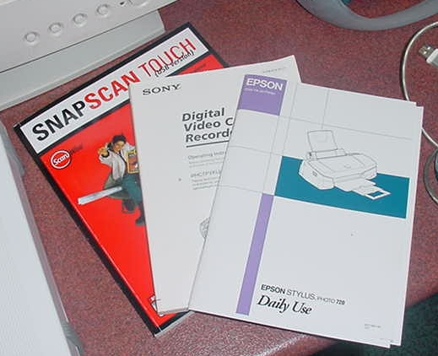
Answer:

Manuals give advice about ….

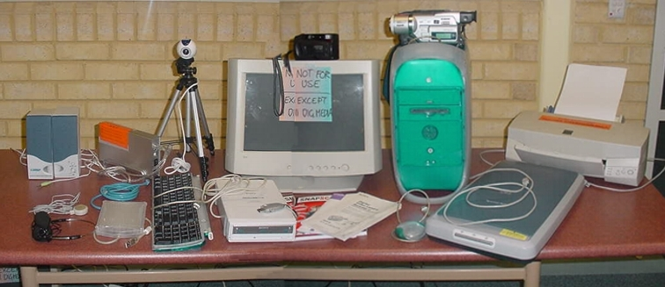
Draw arrows from labelled text boxes to each hardware component

i.e.
Stereo Speakers

Student Name: | Date submitted:
I declare this evidence to have been produced by me the undersigned.

Candidate’s signature:
Title of Portfolio evidence presented (include Unit No and section i.e. 03.05)
:-
□ Outcomes from learning programs (including self-learning and online learning)
□ Assessment feedback (from a trainer or assessor)
□ Observation checklists (from a workplace supervisor or assessor)
□ Written statements or references (including workplace supervisors, community leaders)
□ Job descriptions
□ Work journal
□ Work samples
□ Finished products
□ Product descriptions or specifications (supporting the product samples included)
□ Statutory declarations
□ List others (or delete any from above not provided)
- All work submitted to be word processed and spell checked.
- There must be at least two samples of evidence for each
Element within the Unit of Competency. This is sample 1 / 2
- All work submitted must be of a high quality and meet the
requirements of the Unit of Competency.
Other evidence (List each piece):
Assessor to complete
Evidence is Valid Sufficient Authentic Current
□ □ □ □

Assessor signature: _________________________________Date: _____________
Peter Faulks, BA Soc Sci, Grad Dip Ed, Cert IV AWT
Certificate II in Business assessor/teacher
Assessor to complete

Student is declared Competent Not Yet Competent
□ □

Keep a copy of this report with your file for evidence

